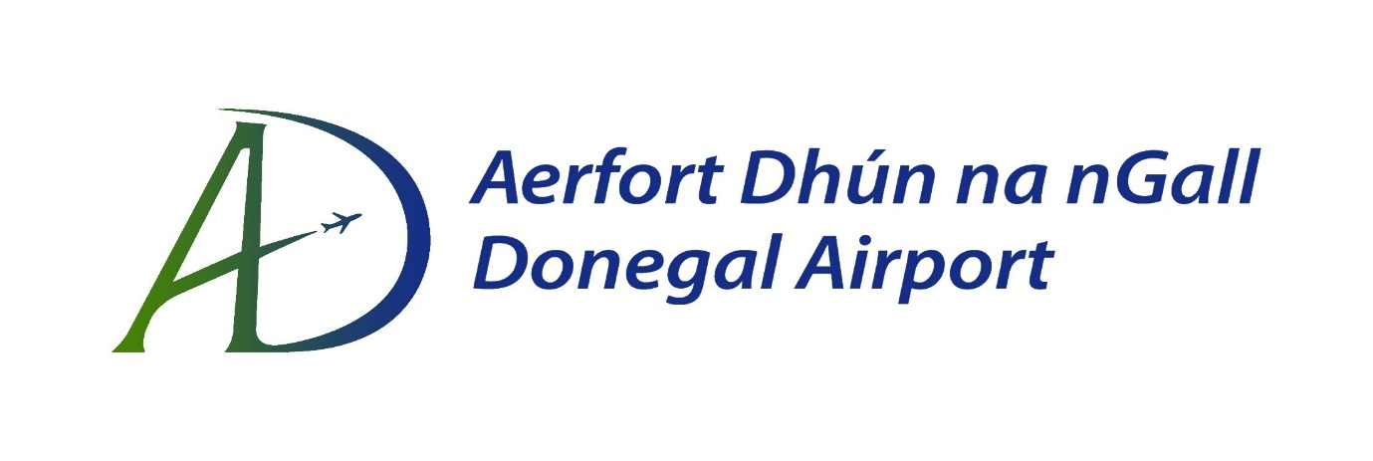
Ráiteas Beartas Teanga
Aithníonn Aerfort Dhún na nGall a thábhachtaí is atá sé seirbhisí a chur ar fáil I nGaeilge agus I mBéarla le freastal go sásúil ar riachtanais na gcustaméirí go léir.

Cuirfidh Aerfort Dhún na nGall go leor acmhainní ar fáil le beartas teanga a fheidhmiú d’fhonn seirhísí a sheachadadh sad á theanga oifigiúil.

Leis an rún seo, tacaíonn an Bainistíocht le hiarrachtaí le seachadadh seirbhísí a bhainneann le gníomhaíochtaí na heagraíochta a fheidhmiú sa dá theanga oifigiúla.
Bainisteoir: 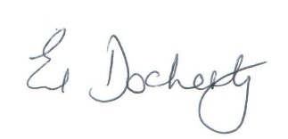
Dáta: 25ú Iúil 2025

Language Policy Statement
Donegal Airport recognises the importance of delivering services in both Irish and English to adequately meet the needs of its entire customer base.
Donegal Airport will supply sufficient resources to implement a language policy to deliver services in both official languages.
The Manager, through this resolution, hereby endorses efforts to implement service delivery in both official languages in all relevant areas related to the organisation’s activities.
Management:
Date: 25th July 2025

